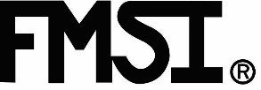

Friction Materials Standards Institute
3069 University Drive, Suite 210
Auburn Hills, MI 48326

The FMSI annual Brake weekend will be held in Naples Florida June 3rd to June 5th.

We are very excited to announce that Dan Sandberg will be the featured guest speaker at our general session Sunday afternoon June 5 says the organizations President Frank Oliveto. FMSI Brake Weekend has several networking events, including the supplier table top exhibit by leading suppliers of brake components, friction materials, and coatings.

The FMSI general session Sunday afternoon will also have a market presentation by Todd Campau of
IHS Markit and a supplier panel discussion chaired by Tom Millsap of Nisshinbo North America.

Founded in 1948 as a trade organization, FMSI and FMS are registered trademarks of Friction Materials Standards Institute
FMSI created the standard part numbering system for Brake and Clutch facings.
Interested in Joining FMSI?
Want to learn more?

Contact us at garrett@fmsi.org

